Angular 6 Beginner Assignment

# Problem Statement

1. Install @angular/cli and create a new angular project with name - “sportsShop”
2. Following will be products array used to populate the shop.
   1. products: Product[] = [

new Product(1, "Product 1", "Category 1", "Product 1 (Category 1)", 100),

new Product(2, "Product 2", "Category 1", "Product 2 (Category 1)", 100),

new Product(3, "Product 3", "Category 1", "Product 3 (Category 1)", 100),

new Product(4, "Product 4", "Category 1", "Product 4 (Category 1)", 100),

new Product(5, "Product 5", "Category 1", "Product 5 (Category 1)", 100),

new Product(6, "Product 6", "Category 2", "Product 6 (Category 2)", 100),

new Product(7, "Product 7", "Category 2", "Product 7 (Category 2)", 100),

new Product(8, "Product 8", "Category 2", "2)", 100),

Product 8 (Category

new Product(9, "Product 9", "Category 2", "Product 9 (Category 2)", 100),

new Product(10, "Product 10", "Category 2", "Product 10 (Category 2)", 100),

new Product(11, "Product 11", "Category 3", "Product 11 (Category 3)", 100),

new Product(12, "Product 12", "Category 3", "Product 12 (Category 3)", 100),

new Product(13, "Product 13", "Category 3", "Product 13 (Category 3)", 100),

new Product(14, "Product 14", "Category 3", "Product 14 (Category 3)", 100),

new Product(15, "Product 15", "Category 3", "Product 15 (Category 3)", 100),

];

1. Create 3 components –
   1. Header Component
   2. Products Component
   3. Categories Component
2. Declare the above array in angular service. Inject service in respective components so that components can use it in business logic.
3. The view of each component should be programmatically defined such that, view displays the count of following in grid layout:
   1. Products
   2. Categories
4. Count value must not be hardcoded. It must be calculated dynamically using code.

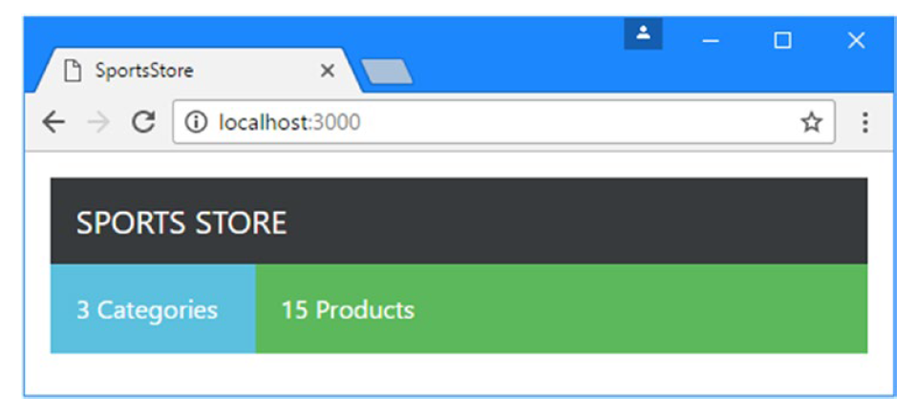

Category1

Category 2

Category 3